TRAVEL TRADERS LLC – OPERATIONS POLICY & PROCEDURE MANUAL
14.264
Post PO Receiving Document [7,2,1,5]
Issued: August 1, 2006 | Page 1 of 4

After a PO Receiving Document has been created, it must be posted in the system. Only posted PO Receiving Documents are transmitted during the polling process. After it is posted, the PO status changes from OPEN or PARTIAL to PARTIAL or FILLED. Partial status happens when some items have been placed into backorder status.

IMPORTANT NOTE: Before posting a PO Receiving Document, it can only be updated or deleted. After posting a PO Receiving Document, it can only be revised or canceled.
IMPORTANT NOTE: All “UNPOSTED” PO Receiving Documents, DSD Receivers and RTVS (negative DSD), MUST be posted or deleted PRIOR to the nightly polling process so they do not prevent the daily store information from being communicated to the corporate office.
IMPORTANT NOTE: Associates that close the store at night MUST be trained on how to review the Receiving Status Report [7,2,4,4] for “UNPOSTED” documents and how to post or delete them. It is preferred that the associate DELETE any unposted documents rather than have a possibly incorrect document posted.

From the Master Menu screen:
Press [7] Optional Modules
Press [2] Receiving/DSD
Press [1] Receive Purchase Orders
Press [5] Post PO Receiving Documents

Below is the screen BEFORE any information has been entered.
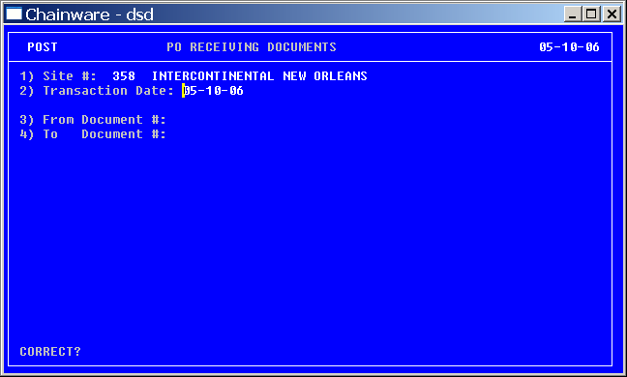
TRAVEL TRADERS LLC – OPERATIONS POLICY & PROCEDURE MANUAL
14.264
Post PO Receiving Document [7,2,1,5]
Issued: August 1, 2006 | Page 2 of 4

Field 1) Site #:
The field will be pre-filled with the store number and name.
Field 2) Transaction Date:
The field will be pre-filled with today’s date.
Field 3) From Document #:
The field will be pre-filled with the lowest PO Receiving Document number created today.
Change this number to the PO Receiving Document number just created and press ENTER.
Note: To select from a list of PO Receiving Documents, press F6. Highlight the PO Receiving Document and press ENTER to select. It should be at the bottom of the list
Field 4) To Document #:
The field will be pre-filled with the number of the PO Receiving Document just created. If not, type the PO Receiving Document number or follow the steps above to search for it.
Press ENTER.
The cursor will go to the Correct? prompt.

TRAVEL TRADERS LLC – OPERATIONS POLICY & PROCEDURE MANUAL
14.264
Post PO Receiving Document [7,2,1,5]
Issued: August 1, 2006 | Page 3 of 4

Below is the screen AFTER the information has been entered.

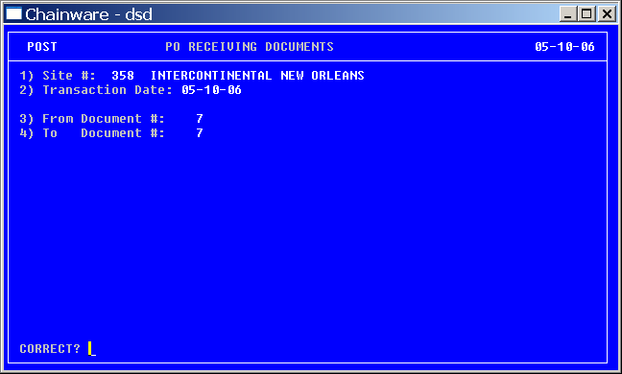

Correct?
Review the screen for accuracy. If any corrections need to be made, type the number of the incorrect field and press ENTER to move the cursor there. Correct the information and press F5 to take the cursor back to the Correct? prompt. Repeat as many times as necessary before pressing enter at the Correct? prompt.
When all of the information is correct, press ENTER.

TRAVEL TRADERS LLC – OPERATIONS POLICY & PROCEDURE MANUAL
14.264
Post PO Receiving Document [7,2,1,5]
Issued: August 1, 2006 | Page 4 of 4

AFTER pressing enter at the Correct? prompt, two message boxes will appear while the system posts the PO Receiving Document.

Some larger PO Receiving Documents may take several seconds to post completely. Do not press any key until the words “Press Any Key to Continue” appear in the message box in the screen.

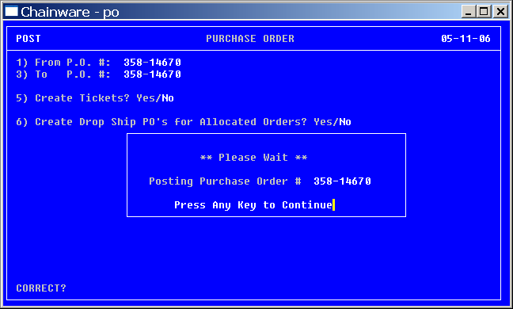

Press ESC five times to return to the Master Menu screen.

Go to Print PO Receiving Document [7,2,4,3].

